|  |
| --- |
| WARNING: This document is uncontrolled unless viewed electronically from its original location. Where an Uncontrolled document is used it is the responsibility of the person using it to ensure that it is the latest version. |

**Configuration and Customization in SFDC**

l

|  |  |  |
| --- | --- | --- |
| **CR Number** | **JIRA Description** | **SRD version used** |
|  | Salesforce Knowledge Management | 1.0 | |

|  |  |  |  |  |  |
| --- | --- | --- | --- | --- | --- |
| **Revision History** | | | | | |
| **Version** | **Date** | **Prepared by** | **Reviewed by** | **Approved by** | **Comments** |
| 0.1 | 11-Dec-2017 |  |  |  | Draft Initiated |

Table of Contents

[1. Introduction 8](#_Toc452386458)

[1.1 Purpose 8](#_Toc452386459)

[2. Scope 8](#_Toc452386460)

[3. Assumptions/Risks 9](#_Toc452386461)

[4. Audience 9](#_Toc452386462)

[5. Acronyms and Definitions 10](#_Toc452386463)

[6. Solution & Design 10](#_Toc452386464)

[6.1 Application Creation in Salesforce 10](#_Toc452386465)

[6.2 Salesforce Knowledge Management High level Flow: 10](#_Toc452386466)

[6.3 Proposed Solution 14](#_Toc452386467)

[Change the Salesforce standard force.com application to Custom application 14](#_Toc452386468)

[6.4 Application Setup Screen Shot: 15](#_Toc452386469)

[7. User Level Solution & Design 16](#_Toc452386470)

[7.1 Users Creation for Salesforce Knowledge Management 16](#_Toc452386471)

[7.2 Profile Creation in Salesforce 16](#_Toc452386472)

[7.3 Role Assignment in Salesforce 16](#_Toc452386473)

[7.4 Permission Settings for User 17](#_Toc452386474)

[8. Knowledge Access Level Solution & Design 17](#_Toc452386475)

[8.1 Knowledge Object Creation and Access Permission 17](#_Toc452386476)

[8.2 Page Layout Creation and Assignment 17](#_Toc452386477)

[9. Data Categories and Groups 18](#_Toc452386478)

[9.1 Data Categories Creation and Group Assignment 18](#_Toc452386479)

[9.2 Data Categories Creation Screen Shot 19](#_Toc452386480)

[9.3 Data Categories Assignment Screen Shot 20](#_Toc452386481)

[10. Approval Process 21](#_Toc452386482)

[10.1 Single Level Approval Process Creation Steps: 22](#_Toc452386483)

[10.2 Multi-Level Approval Process Creation Steps: 24](#_Toc452386484)

[10.3 Multi-Level Approval Process Creation Steps: 26](#_Toc452386485)

[10.4 Approval Process Accessing Screen Shot: 27](#_Toc452386486)

[11. Customer Community Creation Steps: 28](#_Toc452386487)

[11.1 Salesforce Community Description: 28](#_Toc452386488)

[11.2 : Community Creation 29](#_Toc452386489)

[Salesforce Community Creation Screen Shot: 30](#_Toc452386490)

[12. Chatter Enable: 31](#_Toc452386491)

[12.1 Chatter Description: 31](#_Toc452386492)

[12.2 Technical Overview: 32](#_Toc452386493)

[12.3 Salesforce Collaboration High-Level Flow: 33](#_Toc452386494)

[12.4 Chatter Collaboration between two Community Users: 34](#_Toc452386495)

[12.5 Chatter Email Notification: 35](#_Toc452386496)

[12.6 Chatter Collaboration: 36](#_Toc452386497)

[13. Ideas and Idea Zones: 37](#_Toc452386498)

[13.1 Ideas Management: 37](#_Toc452386499)

[13.2 Ideas Management: 38](#_Toc452386500)

[38](#_Toc452386501)

[13.3 Ideas Management: 39](#_Toc452386502)

[14. Chatter Q&A: 40](#_Toc452386503)

[14.1 Technical Overview: 40](#_Toc452386504)

[14.2 Screenshot for Question and Answers: 42](#_Toc452386505)

[14.3 Screenshot for Question and Answers: 43](#_Toc452386506)

[14.4 Screenshot for Question and Answers: 44](#_Toc452386507)

[14.5 Screenshot for Question and Answers: 45](#_Toc452386508)

[14.6 Screenshot for Question and Answers: 46](#_Toc452386509)

[15. Data Categories for Chatter Q&A: 47](#_Toc452386510)

[16. Validation in SKM: 48](#_Toc452386511)

[16.1 Ideas: 48](#_Toc452386512)

[16.2 Prevent Offensive in Ideas Comment Trigger: 49](#_Toc452386513)

[17. Salesforce Sales Cloud Licensee Overview: 51](#_Toc452386514)

[18. Salesforce Service Cloud Licensee Overview: 52](#_Toc452386515)

# Introduction

## Purpose

The purpose of this document is to create Salesforce Knowledge management POC for Charter Communications.

# Scope

|  |  |  |
| --- | --- | --- |
| **Module** | **Description** | **Scope** |
| Knowledge Management in Salesforce | Charter Knowledge management in Salesforce | In Scope |
| Articles for Charter | Charter Article in Salesforce | In Scope |
| Reports and Dashboards | Pictorial representation of Organization data. | In Scope |
| Community Collaboration | Charter Community Users Collaboration in Salesforce and Sharing Articles | In Scope |
| User Adoption | Create reports in Salesforce for monitoring on Community users to get adopt in Internal Org. | In Scope |
| Ideas and Q&A Zones | Create questions and Answer internal Zones and Ideas Management | In Scope |

# Assumptions/Risks

|  |  |  |
| --- | --- | --- |
| **User story** | **Assumption** | **Comments** |
| Knowledge Management in SFDC | Knowledge sharing for Internal organization Users, Community Users, Partner Users and Public Users through Articles. | In Scope |

# Audience

* Development Team
* Administration Team

# Acronyms and Definitions

| Term/Acronym | Definition |
| --- | --- |
| SKM | Salesforce Knowledge Management |
| SFDC | Salesforce Dot Com(Salesforce.com) |

# Solution & Design

## Application Creation in Salesforce

* Upload an Image or Organization logo in SFDC Documents tab.
* Create Name for application
* Select check box Externally Available for accessing Image document in entire organization. And Click Next and Save.

## Salesforce Knowledge Management High level Flow:

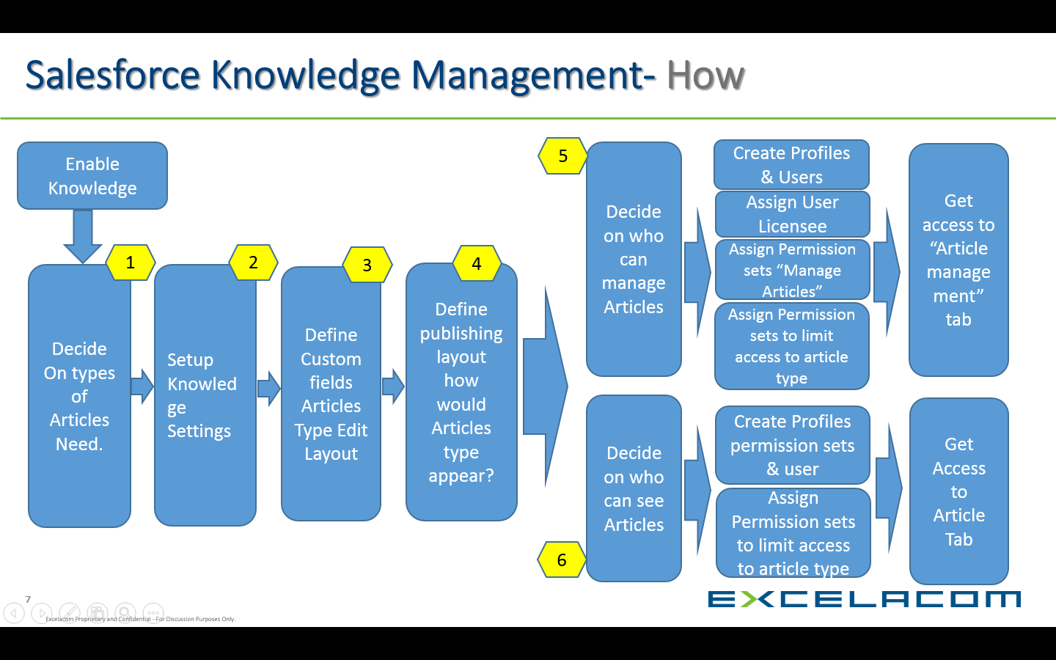

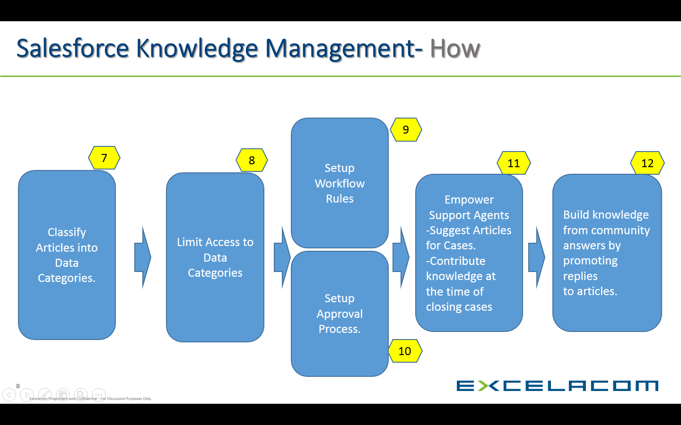

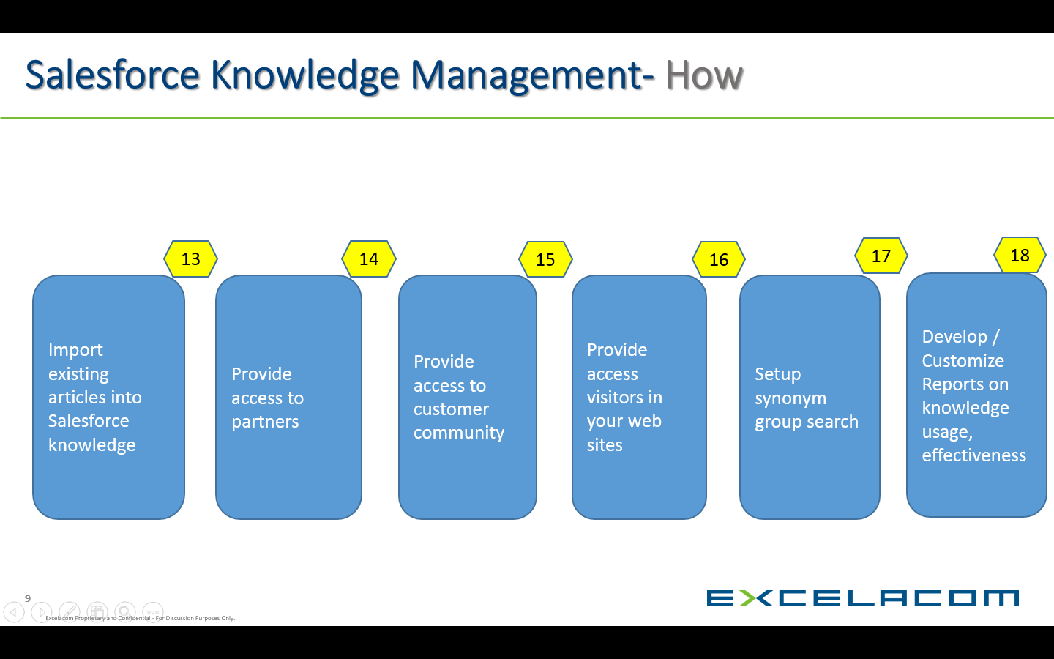

: Salesforce Knowledge management High Level Flow:

## Proposed Solution

## Change the Salesforce standard force.com application to Custom application

* Login with User name and Password.
* Select SFDC Collapsible bar and Changed to Custom application.

##### Technical Overview

**Step: 1**

* Go to Setup Select Create and Click Apps Select Apps
* Click New Button to Create New Custom Application.
* Give App label and App Name.
* Write a Description about the Purpose of the application.
* Click Next.

**Step: 2**

* Click Insert an Image button to select the External Image.
* Select the Drop down for Image Location.
* Pick the Image in list of Images Organization.

**Step: 3**

* Select tabs for the Custom application
* Select the tabs from available tabs
* Select default page Ex: Knowledge
* Click Next button to redirect next Step.
* Click Save to Save the Application.

## Application Setup Screen Shot:

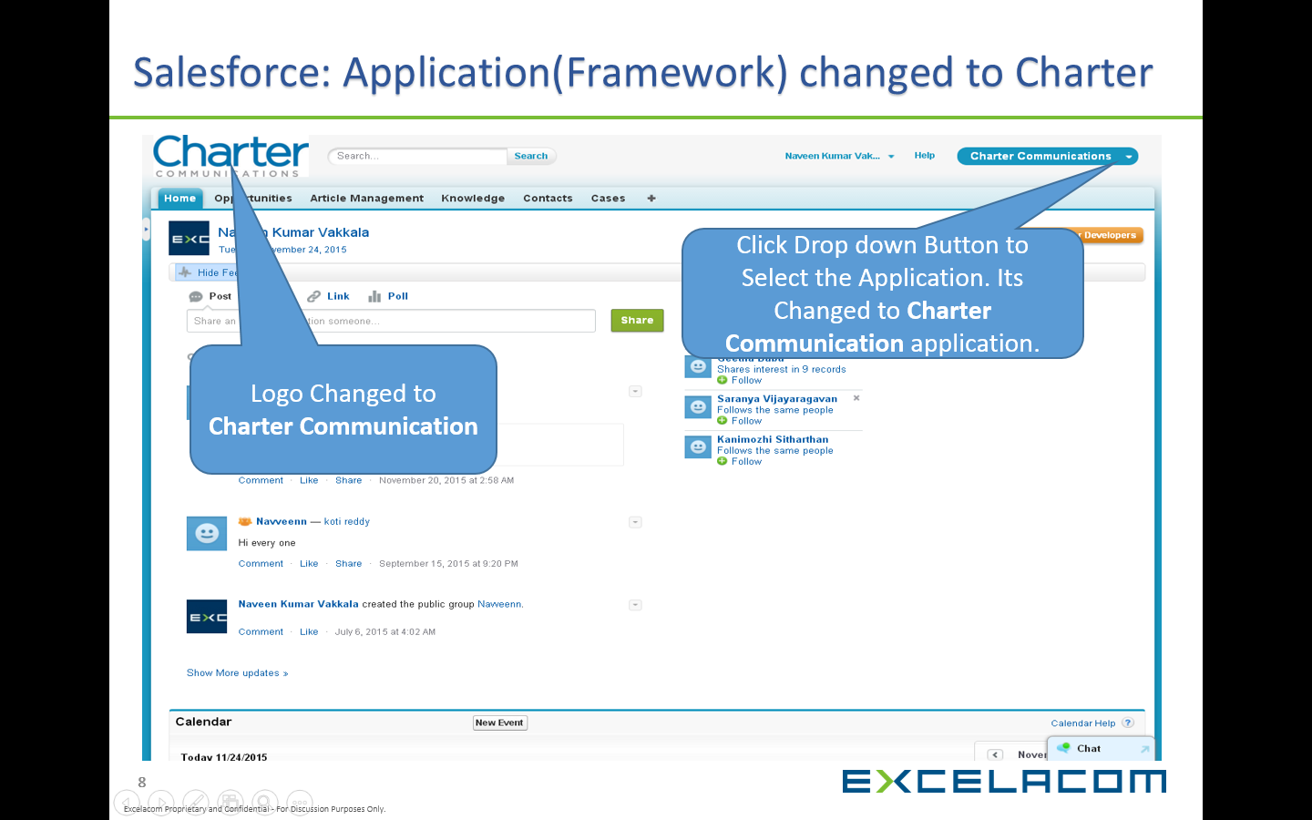

# User Level Solution & Design

## Users Creation for Salesforce Knowledge Management

* Go to Setup and click Manage Users
* Select Users, Click New User
* Select User Licensee as Customer Community User
* Select Custom Profile Ex: Customer Community Profile
* Select Knowledge User for Internal App Only

## Profile Creation in Salesforce

* Go to Setup and click Manage Users
* Select Profiles
* Click New Profile and Clone the Existing profile
* Select Profile Name and Click Save to Save the Profile
* Select the Assignment settings in Profile
* Assign this Profile to New Users

## Role Assignment in Salesforce

* Go to Setup and click Manage Users
* Select Role as a Marketing User (or)
* Knowledge User

## Permission Settings for User

* Go to Setup and click Manage Users
* Select Permission Sets
* Click New button to create New Permission sets
* Select Label Name & API Name
* Select the User Licensee for assigning Permission sets to Proper User
* Click Save to Save the Permission Sets
* Click Edit Properties and Select the Object and field level access to Permission
* Like Knowledge tab Permission Read and Write Permission
* And Custom Field Permission which is in Article Type
* Click Manage Assignment
* Select the User for Which the Permissions is Activated
* Click Save to Save the Permission

# Knowledge Access Level Solution & Design

## Knowledge Object Creation and Access Permission

* Go to Setup Click Customize and Select Knowledge
* Select Knowledge Article Type and Click New Article Type
* Select Label ,Plural label and Object Name
* Click Save to Save the Article Type.
* Go to Knowledge Settings
* Select Article Summary as an Internal, Customer and Partner

## Page Layout Creation and Assignment

* Select the Article Type Where create page layout
* Go to Page layout Section
* Click New Button to create Page layout
* Give Page Layout name and Click Save
* Edit Page layout and Drag the appropriate field to page layout
* Click Save and Assign page layout to Object

# Data Categories and Groups

## Data Categories Creation and Group Assignment

* Go to Setup and Select Customize Select Data Categories
* Select Data Categories Setup Click New Button to Create new Categories
* Create Categories group and Inside the group create Data Categories
* Click Save to Save the Data Categories
* For Enable Data Categories in Knowledge Management tab
* Activate the Data Categories Group
* Limitation for Data Categories 3 is maximum for Activate.

## Data Categories Creation Screen Shot

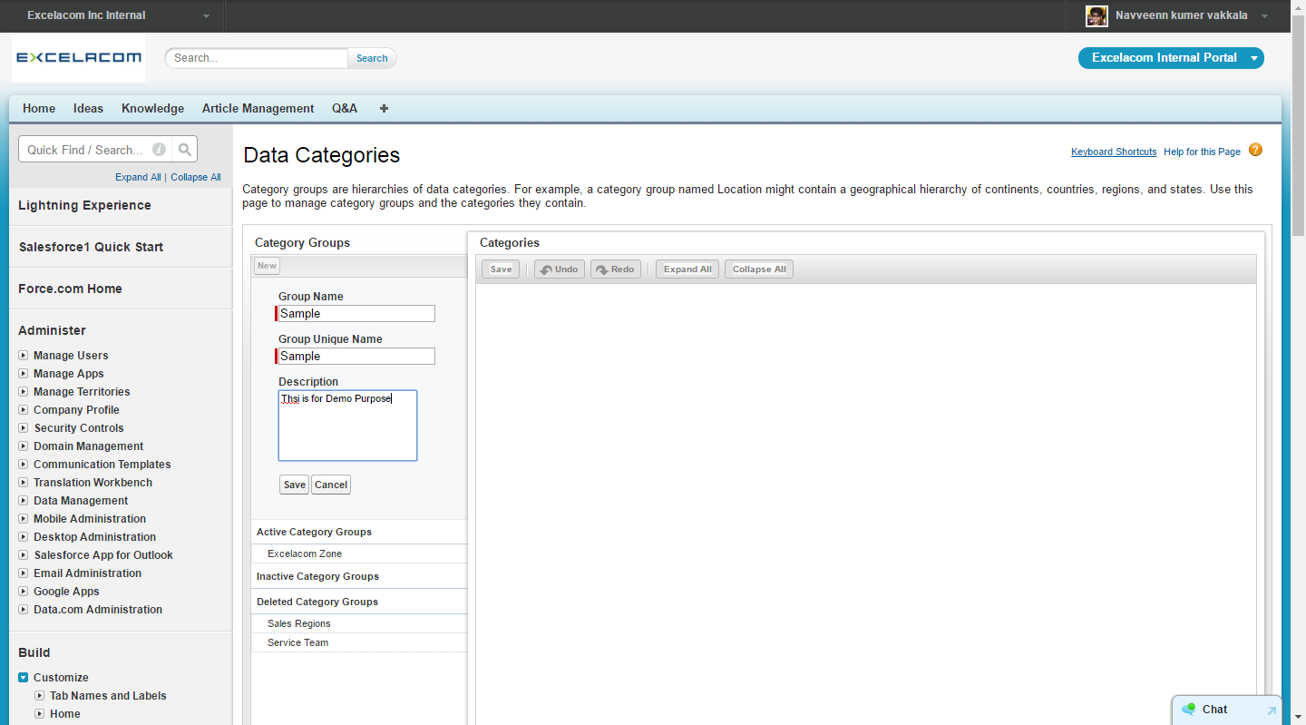

## Data Categories Assignment Screen Shot

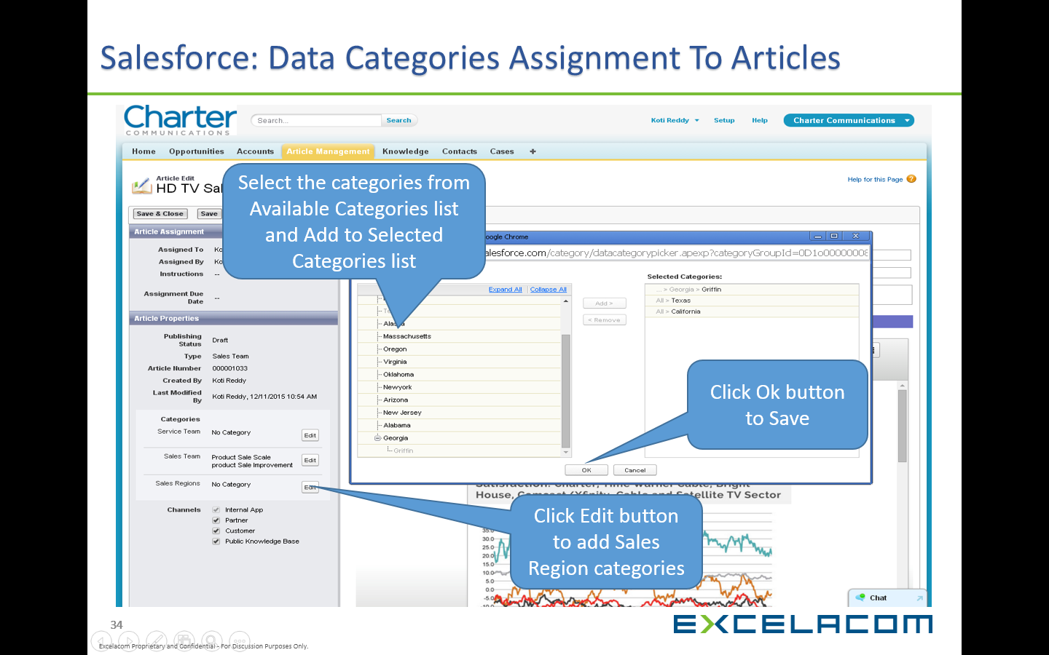

# Approval Process

* Approval process is an automated process in organization can use to approve Articles in Salesforce
* Approval process specifies the steps necessary for an article to be approved and who must approve it at each step.
* Approval Steps can apply to all articles included in the process, or just articles that meet certain administrator-defined criteria.
* Approval process also specifies the actions to take when an articles is approved, rejected, recalled, or first submitted for approval.
* Approval Process are Two Type:

1. Single Level Approval Process
2. Multi-Level Approval Process

## Single Level Approval Process Creation Steps:

* Go to Setup and Select Create & Go to Workflows and Approvals
* Multi-Level Approval Process

**Approval Process:**

* Go to Setup and click Create.
* Select Workflow & Approvals, click Approval Process.
* Select Manage Approval Process for Article Type.
* Select Create New Approval Process, click Use Standard Setup Wizard.
* Enter Name and Description, click next.
* Select Specify Entry Criteria, click next.
* Check Record edit ability Properties click next.
* Select Approval Assignment Email Template, click next.
* Select Approval Process for Internal Portal, click next.
* Select Initial Submitters and Click Save.
* Click Activate Button for Activate the Approval process.

Step 1

**Initial Submission Actions**

* Click Add New Button select Email Alert Save.

Step 2:

**Approval Steps**

* Enter Name and Description, click next.
* Specify Step Criteria, click next.
* Select Single User Assign to Approver, click Save

Steps 3:

**Final Approval Process**

* Click Add New Button select Email Alert.

Step 4:

**Final Rejection Action**

* Click Add New Button select Email Alert.

Step 5:

**Recall Action**

* Click Add New Button select Email Alert.

## Multi-Level Approval Process Creation Steps:

* Go to Setup and click Create.
* Select Workflow & Approvals, click Approval Process.
* Select Manage Approval Process for Article Type.
* Select Create New Approval Process, click Use Standard Setup Wizard.
* Enter Name and Description, click next.
* Select Specify Entry Criteria, click next.
* Check Record edit ability Properties click next.
* Select Approval Assignment Email Template, click next.
* Select Approval Process for Internal Portal, click next.
* Select Initial Submitters and Click Save.
* Click Activate Button for Activate the Approval process.

Step 1: **Initial Submission Actions**

* Click Add New Button select Email Alert Save.

Step 2: **Approval Steps**

* Enter Name and Description, click next.
* Specify Step Criteria, click next.
* Select Multiple Users Assign to Approver.
* Check Require UNANIMOUS approval, click save.

Steps 3: **Final Approval Process**

* Click Add New Button select Email Alert.

Step 4: **Final Rejection Action**

* Click Add New Button select Email Alert.

Step 5: **Recall Action**

* Click Add New Button select Email Alert.

## Multi-Level Approval Process Creation Steps:

**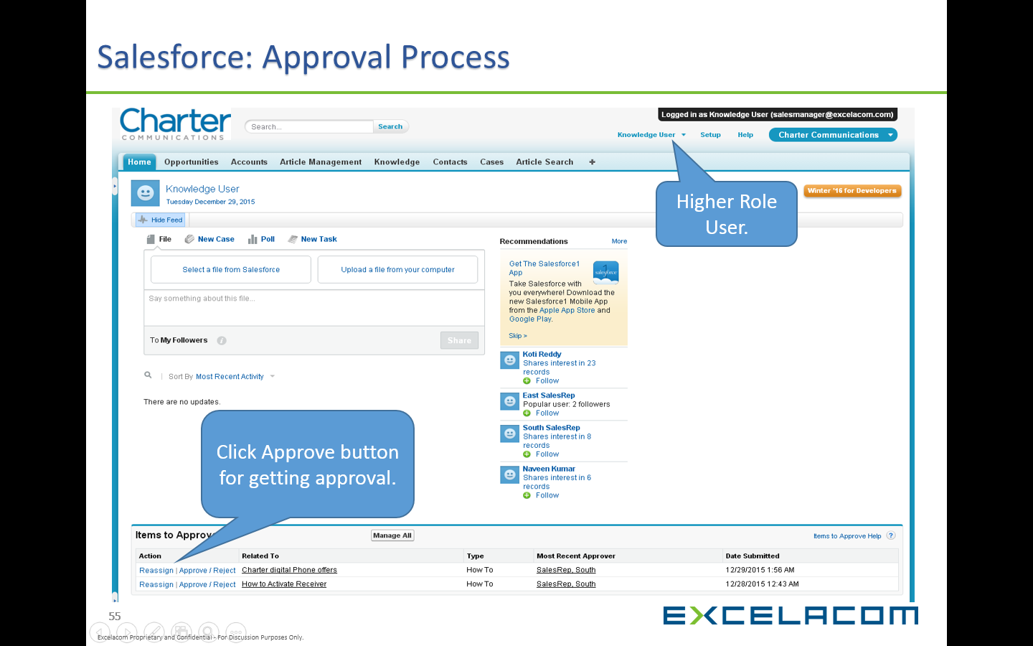**

## Approval Process Accessing Screen Shot:

**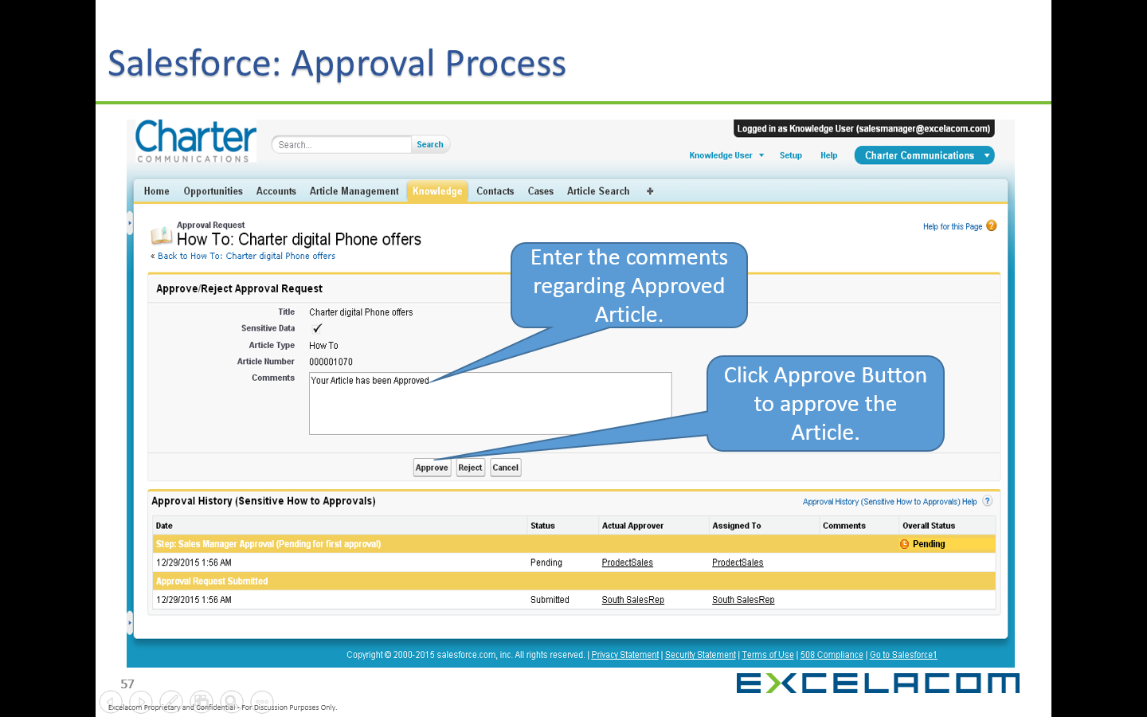**

# Customer Community Creation Steps:

## Salesforce Community Description:

* Communities are branded spaces for our employees, customers, and partners to connect.
* Communities are a great way to share information and collaborate with people outside our company who are key to our business.
* We can customize and create communities to meet our business needs.
* Salesforce Communities is the only community platform that combines the power of social with mobile participation, trusted security, and direct connection to business processes.

## : Community Creation

* Go to Setup and click Customize.
* Select All Communities, click New Community Button.
* Choose a Template as Salesforce Tabs + Visual force.
* Name Your Community, click Create Community.
* Click Go to Community Management.
* Click Administration and Select Settings, click Activate Community.
* Click Manage and Select Administration.
* Select Available Profiles for Customer Community User.
* Select Available Permission Sets for Customer Community User.
* Select Tabs as Knowledge, Ideas, Home and Q&A, click Save.
* Select Branding Header and Footer choose Colors, click Save.
* Select Login and Registration Choose Header logo, Select Login Page.
* Create Logout URL for Community Logout Page.
* Check Self Registration Choose Profile and Account, Save.
* Enter Name and Email Address for Notification.
* Choose email Templates for Forget Password and Change Password.

Login with Customer Community User using Community URL. Get Community User Credential from already Created Users.

## Salesforce Community Creation Screen Shot:

**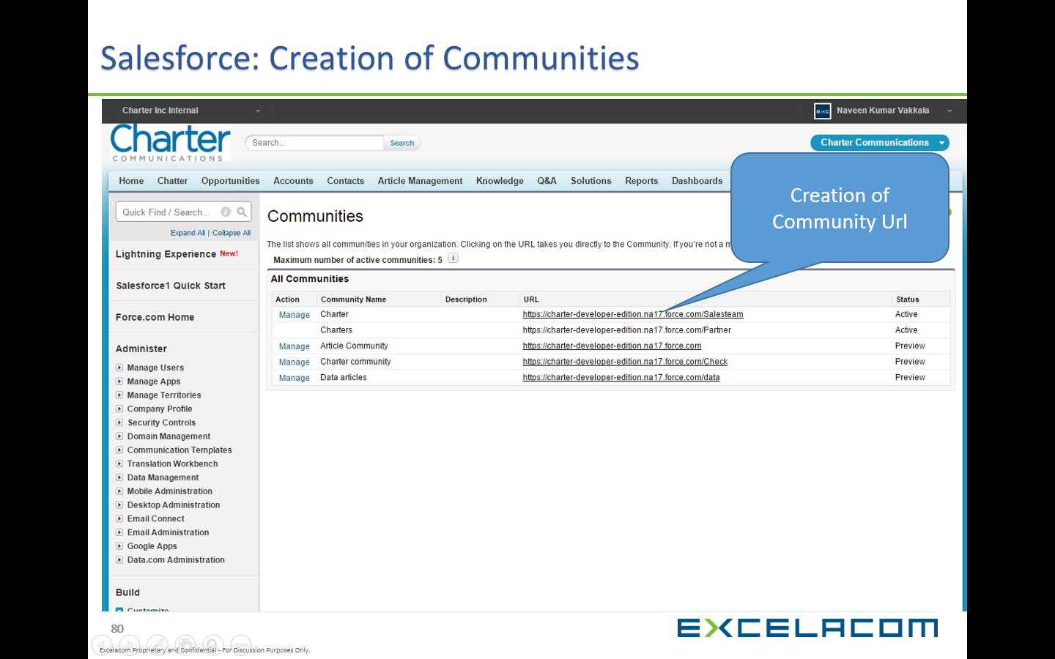**

# Chatter Enable:

## Chatter Description:

* Chatter is a Salesforce collaboration that helps us connect with people and share business information securely and in real time.
* This is great Communicator because it allows our sales team to keep all its data and information in one place.
* Chatter supports the concept of Groups to faster collaboration between a specific set of users.
* Use Chatter features like feeds, profiles, groups, and more to share information, collaborate, and keep up with the latest updates in your company.

## Technical Overview:

* Select All Communities click Manage Community.
* Select Administration & Click Tabs Enable Chatter.
* Go to Setup Select Customize, Click Chatter.
* Select Chatter Setting Check Enable, Check Groups, Check Rich Link Previews in Feed.
* Check Emotions in Feed and Allow Approvals.
* Check Customer Invitations **and** check Actions in the Publisher.
* Check Recommendations in the Feed, Post and comment Modification and Check Rich Text Posts, Click Save.
* Select Chatter and Click Feed tracking.
* Select Tracked Object and Check Enable Feed Tracking.

## Salesforce Collaboration High-Level Flow:

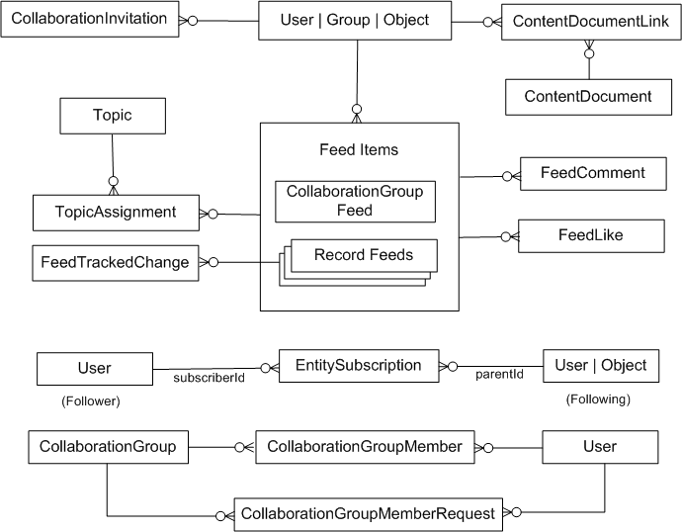

## Chatter Collaboration between two Community Users:

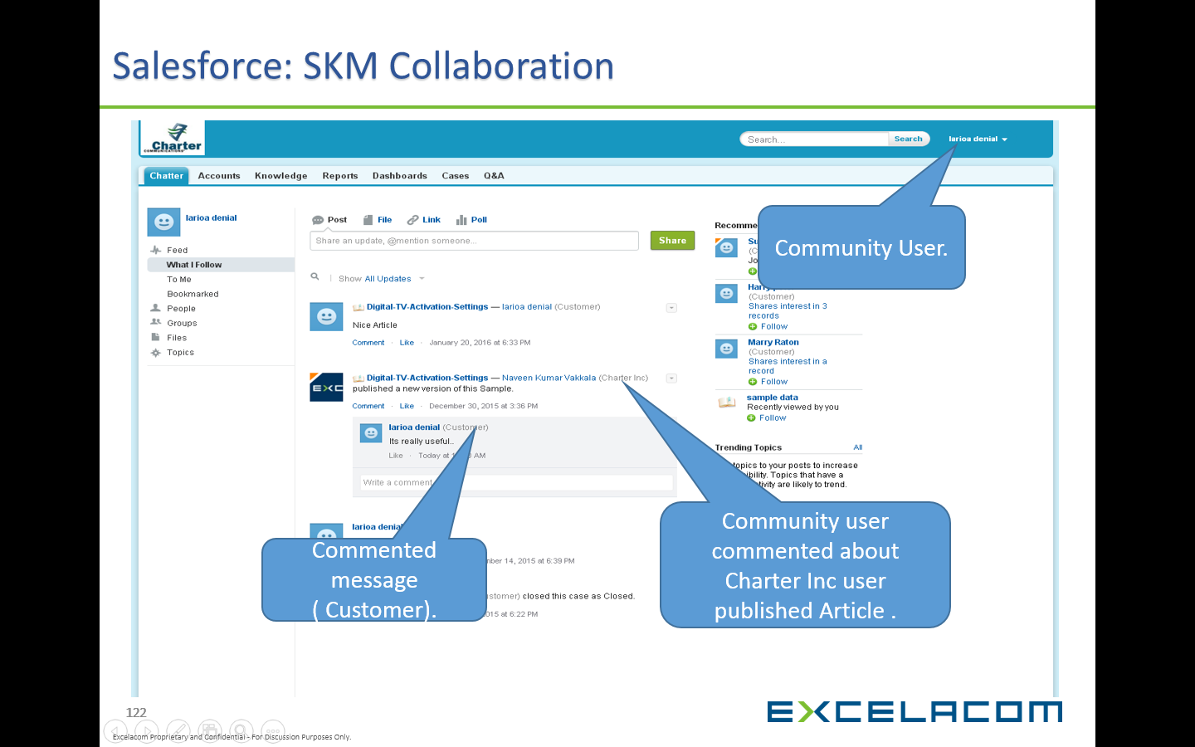

## Chatter Email Notification:

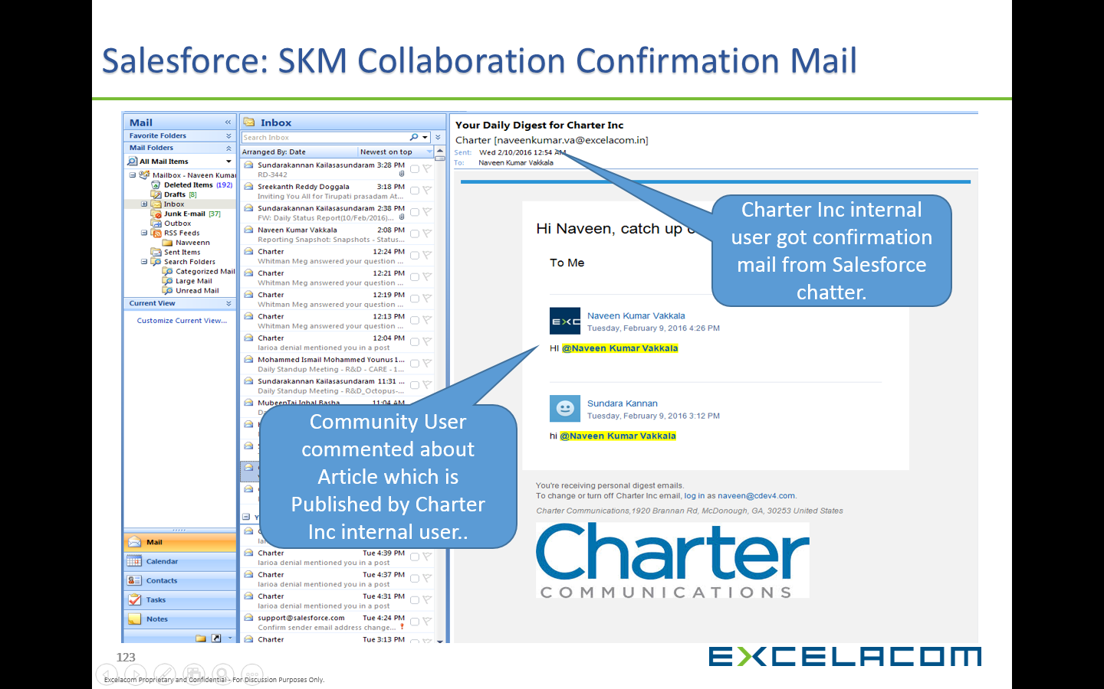

## Chatter Collaboration:

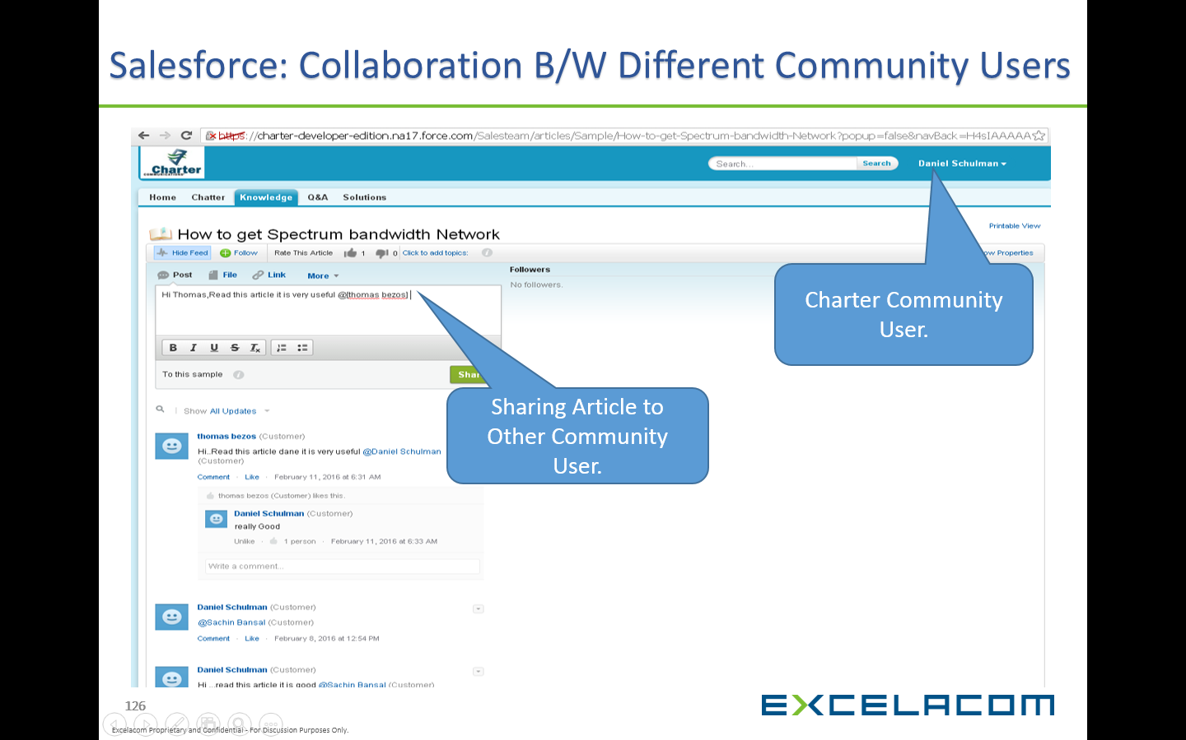

# Ideas and Idea Zones:

* Click Administration and Select Tabs Enable Ideas
* Go to Setup Select Ideas, Check Enable Ideas and click Save.
* Select Ideas and Click Idea Zone.
* Click New Button to Create Idea Zone, Edit.
* Check Enable for Chatter Answers and Enable Private Question.
* Check Active and Save.

## Ideas Management:

Ideas Overview. Ideas is a community of users who post, vote for, and comment on ideas. An Ideas community provides an online, transparent way for you to attract, manage, and showcase innovation. Salesforce offers its own Ideas community for Salesforce users to submit **product feedback** and suggest new features.

## Ideas Management:

## E:\Screenshot_Capture\2016-05-30_142808.png

## Ideas Management:

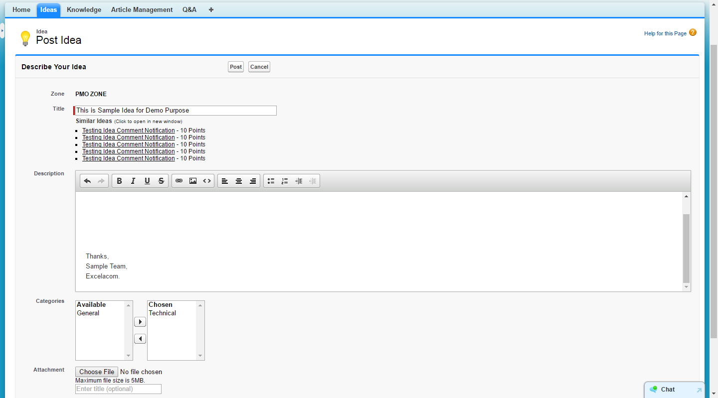

# Chatter Q&A:

1. Chatter Answers is a self-service and support community where users can post questions and receive answers and comments from other users or your support agents.
2. Chatter Answers brings together Case, Questions and Answers, and Salesforce Knowledge articles in a unified experience.

3. Customers can post a question to the community for help. Other members of the community can post answers or follow the question to receive email notifications on subsequent posts.

## Technical Overview:

* Go to Setup select Customize and click Chatter Answers.
* Select chatter Answer Setting click Edit and check Enable Chatter Answers, Click Save.
* Select Chatter Answers and Click Chatter Answer Zone, Select Available Zone.
* Choose Category and click Save.

**Refer these in Below Diagram:**

**1. Search**: Customers can search for existing questions before they post their own.

**2. Filter** and **Sort**: Community members and support agents can select different viewing options for questions in the feed.

**3. Question**: Customers can post a question to the community for help. Other members of the community can post answers or follow the question to receive email notifications on subsequent posts.

**4. Browse by Category**: If categories are enabled in the community, members can click the category name to show questions related to that category **Filter** and **Sort**: Community members and support agents can select different viewing options for questions in the feed.

**5. Reputation**: Community members can earn points and ratings that display on hover their photos in the feed

**6. Comment**: Community members and support agents can comment on the question, and the customer or agent can select a comment as the best answer

## Screenshot for Question and Answers:

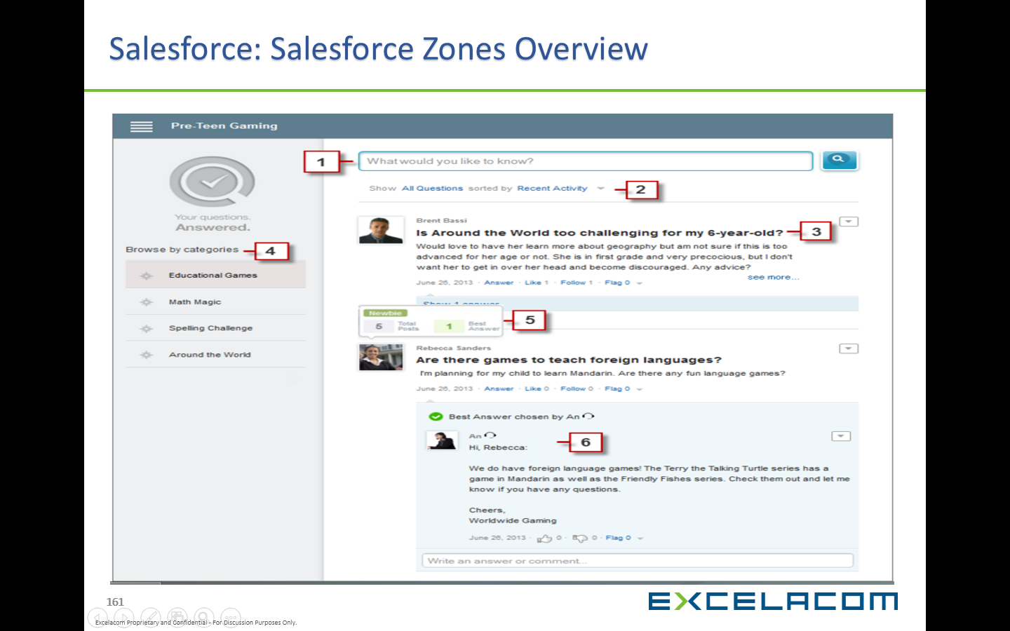

## Screenshot for Question and Answers:

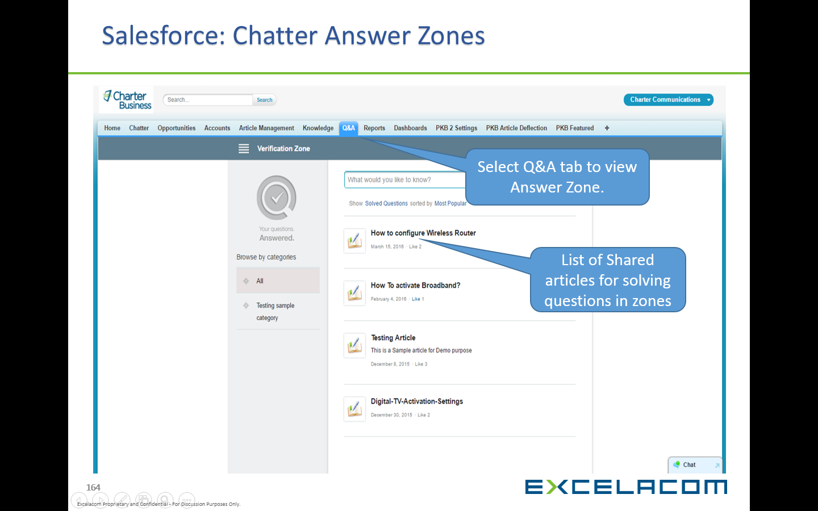

## Screenshot for Question and Answers:

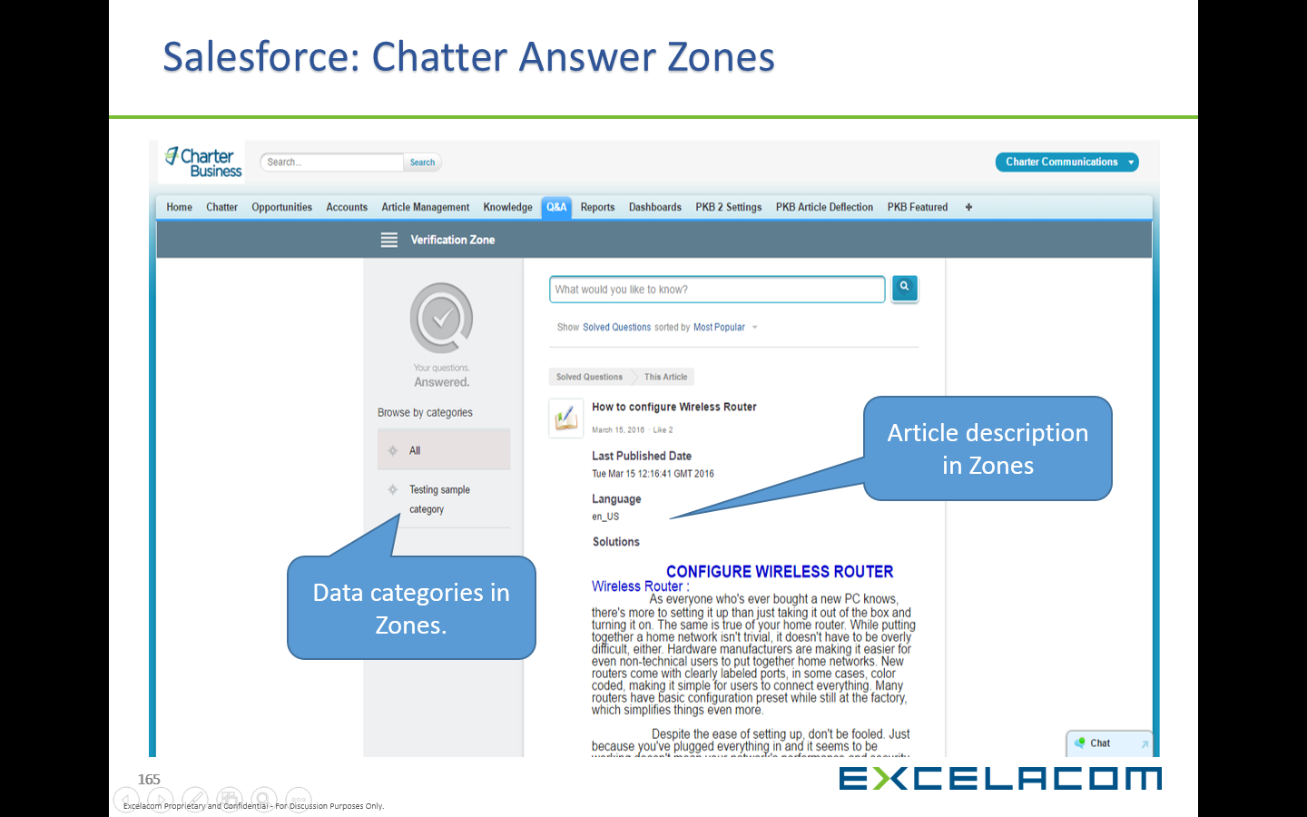

## Screenshot for Question and Answers:

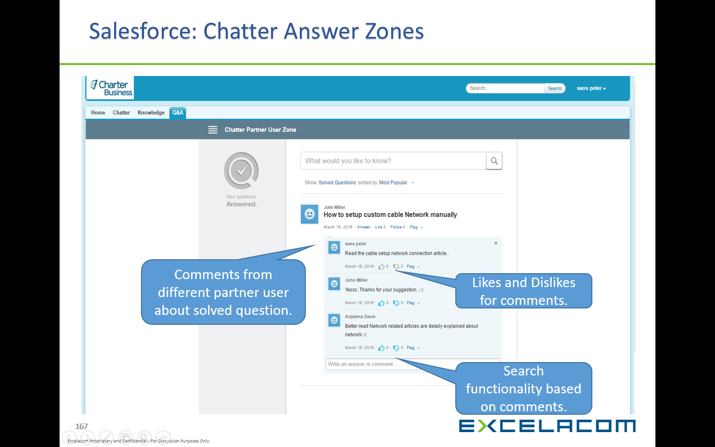

## Screenshot for Question and Answers:

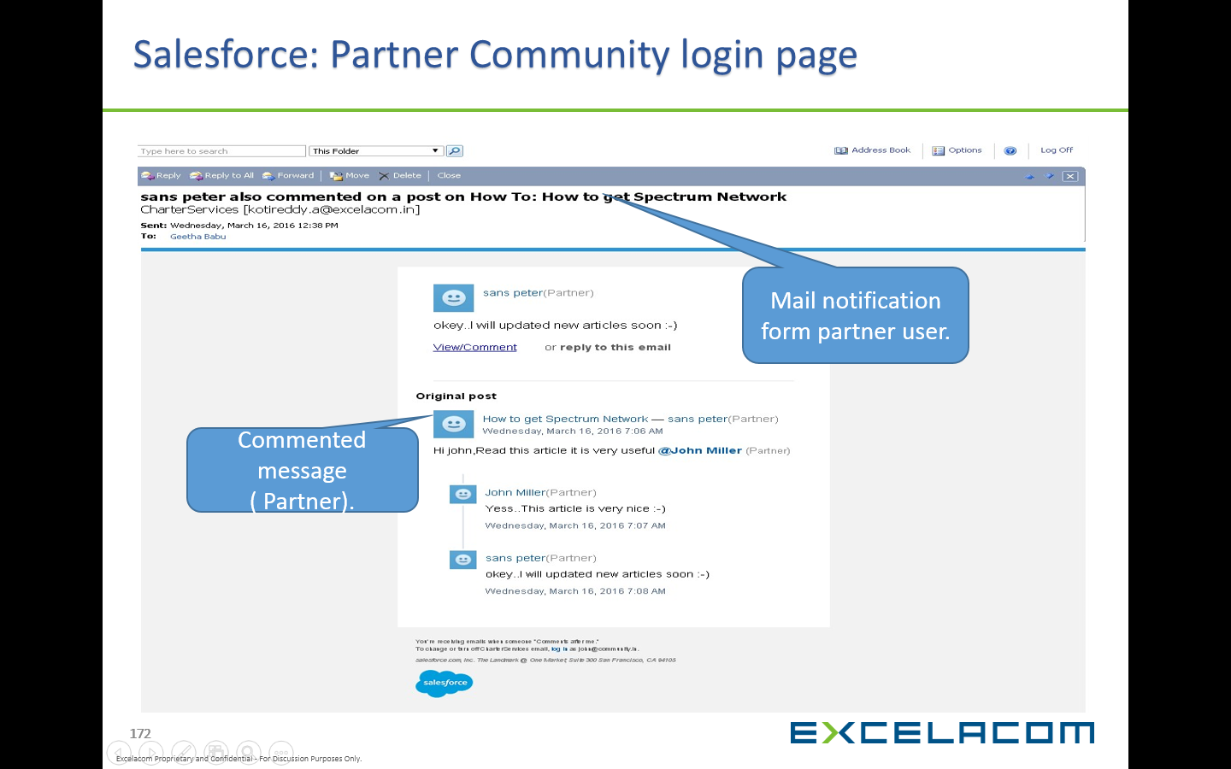

# Data Categories for Chatter Q&A:

* Go to Setup Customize Select Data Categories and Click Data category setup.
* Select New Button for Creating Data Categories.
* Select Data Categories and Click Default Data Category Visibility.
* Select Answer Zone Edit and Click All Category, Click Save.
* Go to Setup Manage User and Click Permission sets.
* Choose Available Permission set and Select Data Category Visibility, Click All Category Save.
* Go to Setup Customize Chatter Answer and click Data category Assignments.
* Click Edit and Choose Category for Assignment.
* Go to Setup Customize Chatter Answer Zones and Select Available Zone, Choose Enabled Data category, Click Save.

# Validation in SKM:

## Ideas:

* Go to setup Select Customize and Click Idea Comment Trigger.
* Click Idea Comment Trigger and Select Available Trigger (i.e.) email on Comment.

**Email on Comment Trigger**

|  |
| --- |
| trigger emailOnComment on IdeaComment (after insert) {  List <Messaging.SingleEmailMessage> s=new List<Messaging.SingleEmailMessage>();  //Create map to get Idea ID  Map<id,Idea> mp=new Map<id,Idea>([select id,createdByid from Idea]);  //Create map to get all User email address  Map<id,User> mp1=new Map<id,User>([select id,Email from User]);  for (IdeaComment o : Trigger.new) {  // get email address of Idea creator  String userEmail = mp1.get(mp.get(o.Ideaid).createdByid).Email;  Messaging.SingleEmailMessage mail = new Messaging.SingleEmailMessage();  String[] toAddresses = new String[] {userEmail};  mail.setToAddresses(toAddresses);  // Set email subject  mail.setSubject('Automated email notification on idea comment: Comment created');  // set comment body  mail.setPlainTextBody('Hi, new comment is posted,Description:>>'+o.CommentBody);  s.add(mail);  } |

## Prevent Offensive in Ideas Comment Trigger:

|  |
| --- |
| trigger ideaOffensive on IdeaComment (Before Insert,Before Update) {  for(IdeaComment a:Trigger.new)  {  if (a.CommentBody != null && a.CommentBody.containsIgnoreCase('stupid'))  {  a.CommentBody.addError('Comment having Offencive word'); // prevent update  }  if (a.CommentBody != null && a.CommentBody.containsIgnoreCase('idiot')||a.CommentBody != null && a.CommentBody.containsIgnoreCase('pig'))  {  a.CommentBody.addError('Comment having Offencive word'); // prevent update  }  if (a.CommentBody != null && a.CommentBody.containsIgnoreCase('countrybruite')|| a.CommentBody != null && a.CommentBody.containsIgnoreCase('shit'))  {  a.CommentBody.addError('Comment having Offencive word'); // prevent update  }  if (a.CommentBody != null && a.CommentBody.containsIgnoreCase('donkey'))  {  a.CommentBody.addError('Comment having Offencive word'); // prevent update  }  if(a.commentbody!=null && a.commentbody.containsignorecase('MAD'))  {  a.commentbody.adderror('Comment having offensive word');  }  if(a.commentbody!=null && a.commentbody.containsignorecase('Dog'))  {  a.commentbody.adderror('Comment having offensive word');  }  } |

# Salesforce Sales Cloud Licensee Overview:

**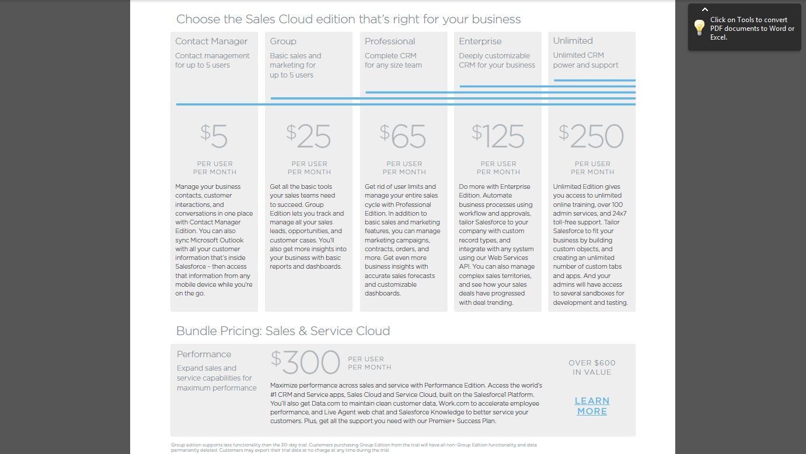**

# Salesforce Service Cloud Licensee Overview:

